Members of Group 7:

6230252121 Tarm Kalavantavanich

6231304321 Kittipong Deevee

6231353021 Raviporn Akekunanon

6231358221 Wipawan Temtheerakij

## Task 6: Summary in 80-100 words

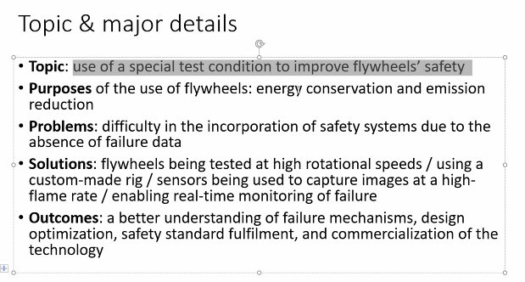

A FlySafe research collaboration created a test condition to improve the safety of flywheel systems. The system provides a potentially clean, cost-effective, fuel saving and emission reducing method of storing energy in vehicles. However, the incorporation of safety systems have had to be conservatively engineered. Consequently, they conduct the custom-built test rig to analyze flywheel operation by monitoring the behavior of flywheels with imaging and sensors and shooting the high frame rate to capture footage. As a result, the study will offer new flywheel safety standards to promote a higher level of design optimization and accelerate the commercialization.

(98 words)

Members of Group 7:

6230252121 Tarm Kalavantavanich

6231304321 Kittipong Deevee

6231353021 Raviporn Akekunanon

6231358221 Wipawan Temtheerakij

Task 8

The researchers experimented on how constructions made with reinforced concrete frames and masonry infill walls withstand earthquakes. Nowadays, thousands of buildings are prone to earthquakes and may need to be demolished. Formerly, researchers have only experimented on sections of structure using low-to-moderate levels of vibration. However, for this experiment, they record the current condition of the building, then install a spinning device on the roof to simulate the vibrations of an earthquake. Finally, cameras and sensors are installed to observe the damage. The result will be useful for seismic research.